**SQL Injection**

Go to localhost/sqli-basic in Kali

Input username ‘Jack’ and password ‘123’ then press login.

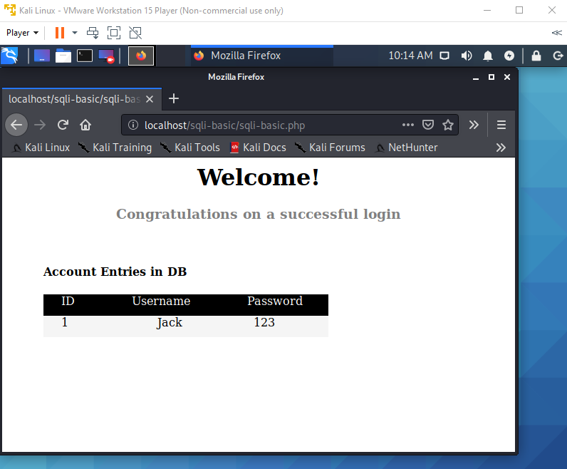

Enter for wrong credentials.

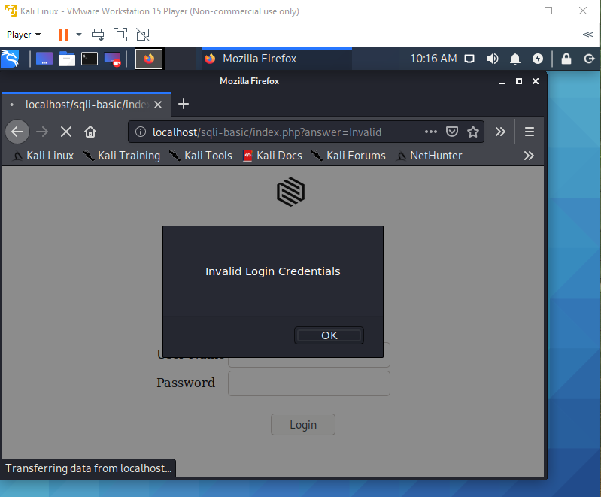

Input for SQL Injection [ ‘ OR’1’=’1 ]

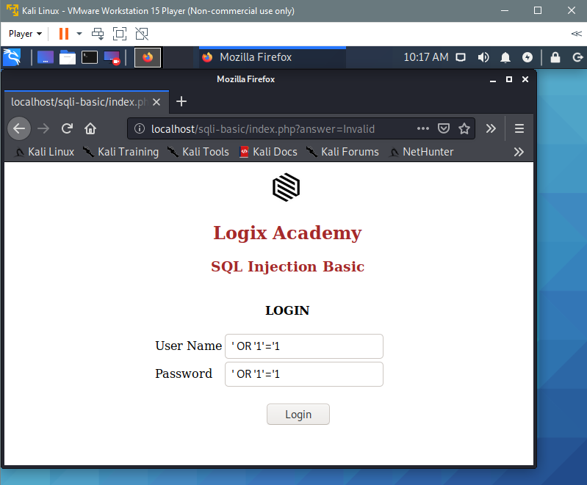

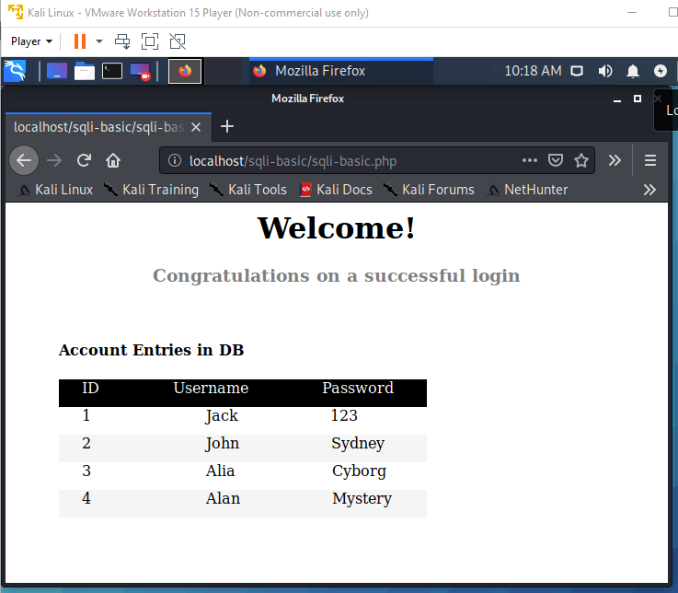

This is because we structured a query that is always true.

Go to localhost/sqli-union

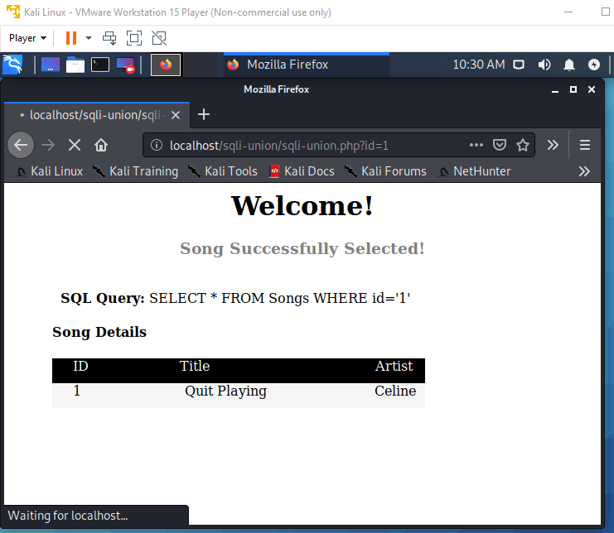

Insert ‘ OR ‘1’=’1 on URL

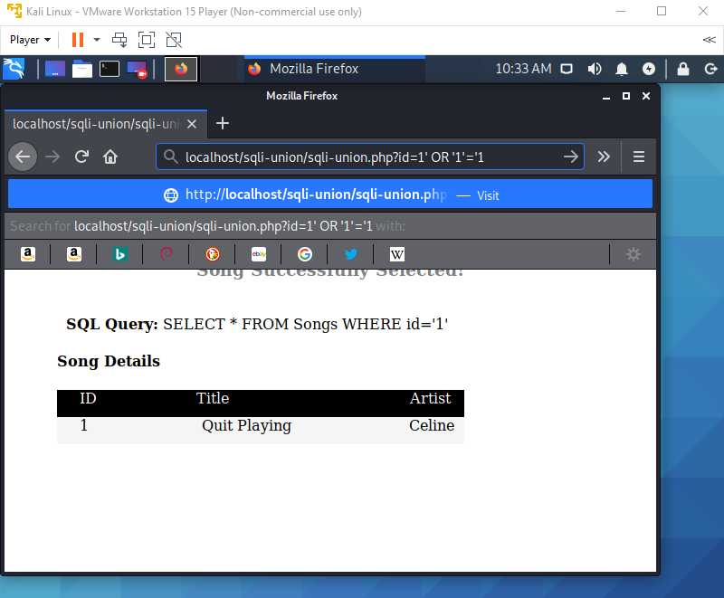

Resulted in  
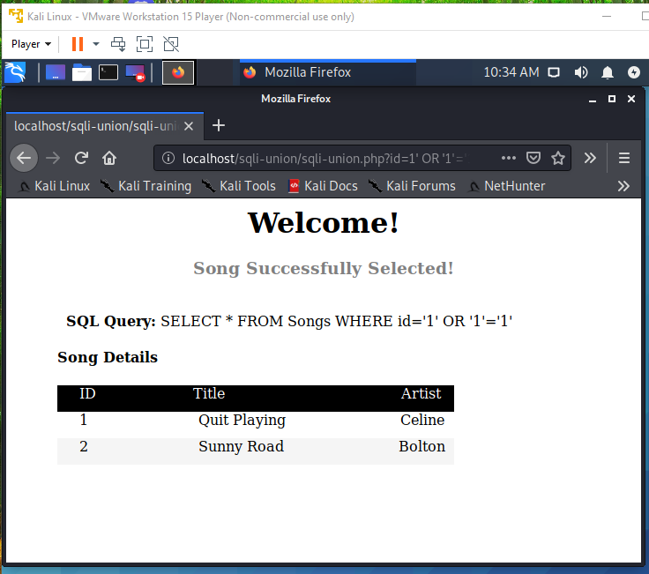

Next, put UNION;

‘ UNION SELECT * FROM Users WHERE ‘1’ = ‘1

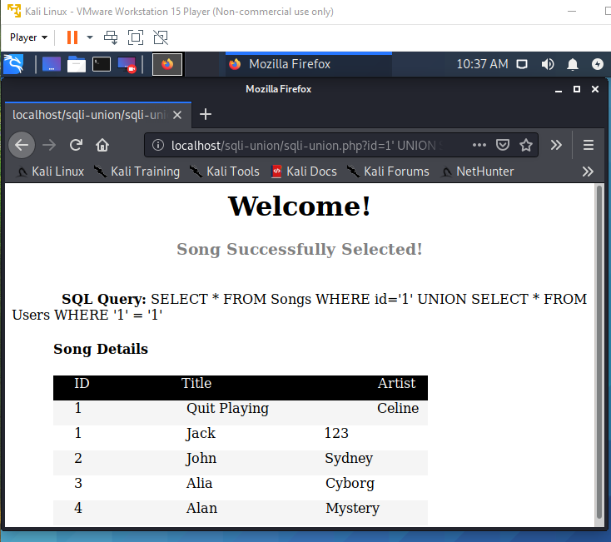

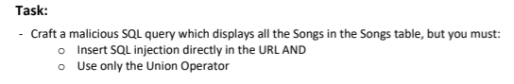

Insert ’ UNION SELECT * FROM Songs WHERE ‘1’=’1 to the URL

